WEEK O
NAME: YOGADHARSHINI N K
ROLL NO: 241801324
Q1-CALCULATE AREA AND PERIMETER
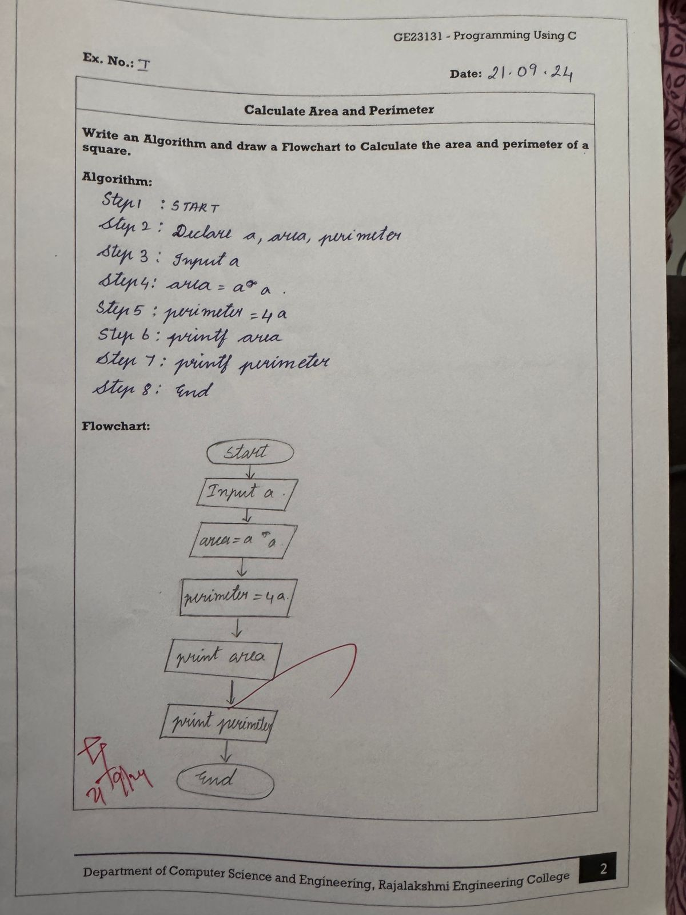

NAME: YOGADHARSHINI N K
ROLL NO: 241801324
Q2-DAYS TO YEAR CONVERSION
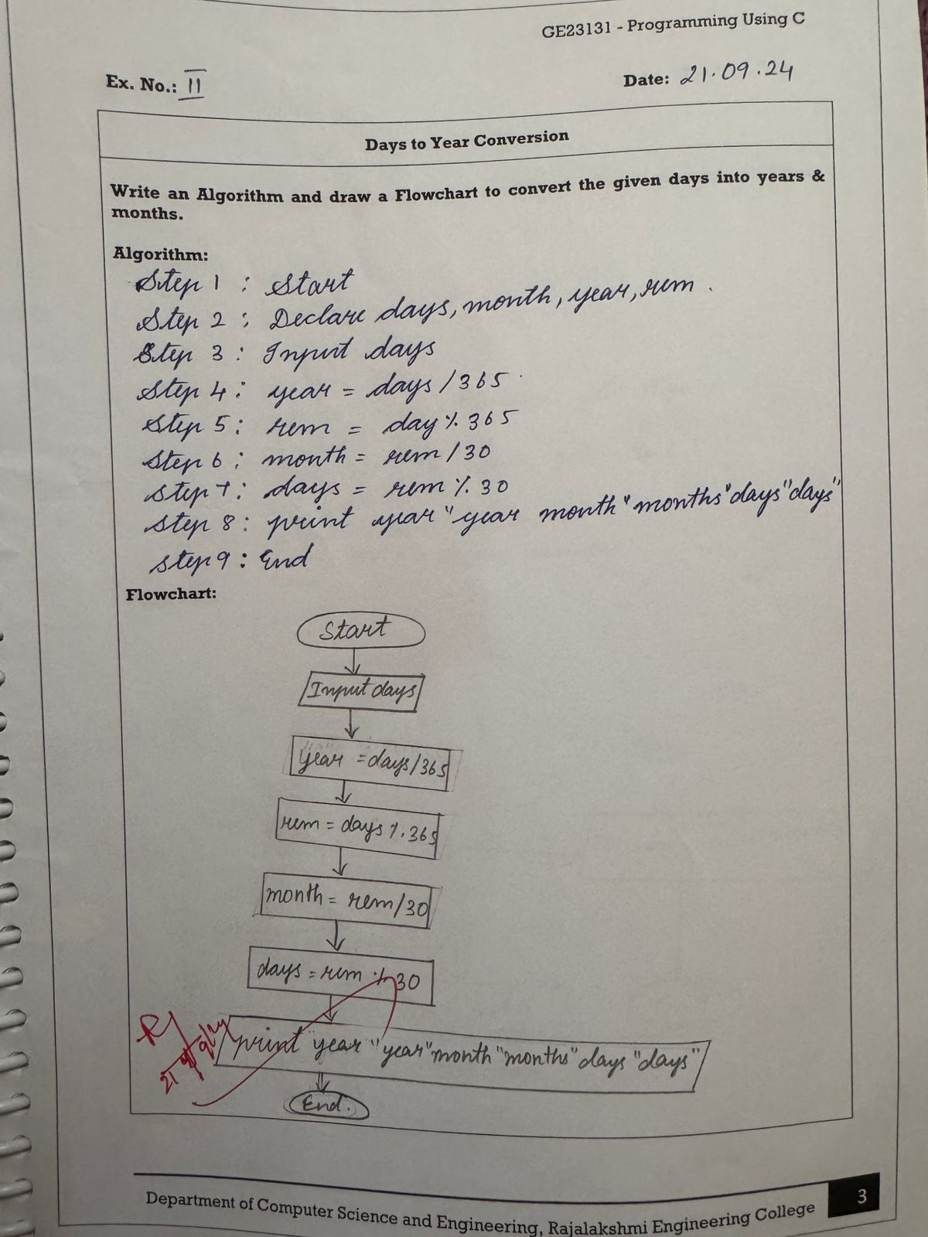
NAME: YOGADHARSHINI N K
ROLL NO: 241801324
Q3-PRIME NUMBER
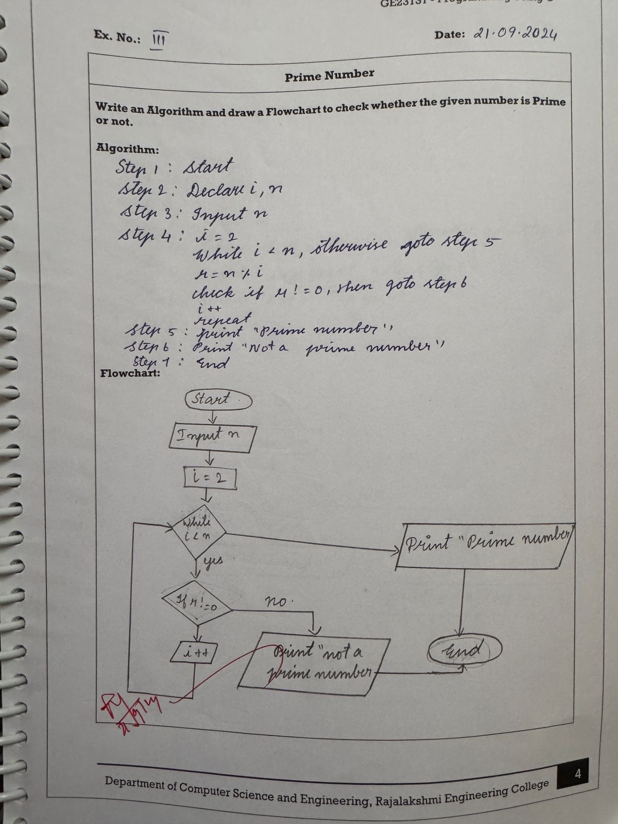
NAME: YOGADHARSHINI N K
ROLL NO:241801324
Q4-LEAP YEAR
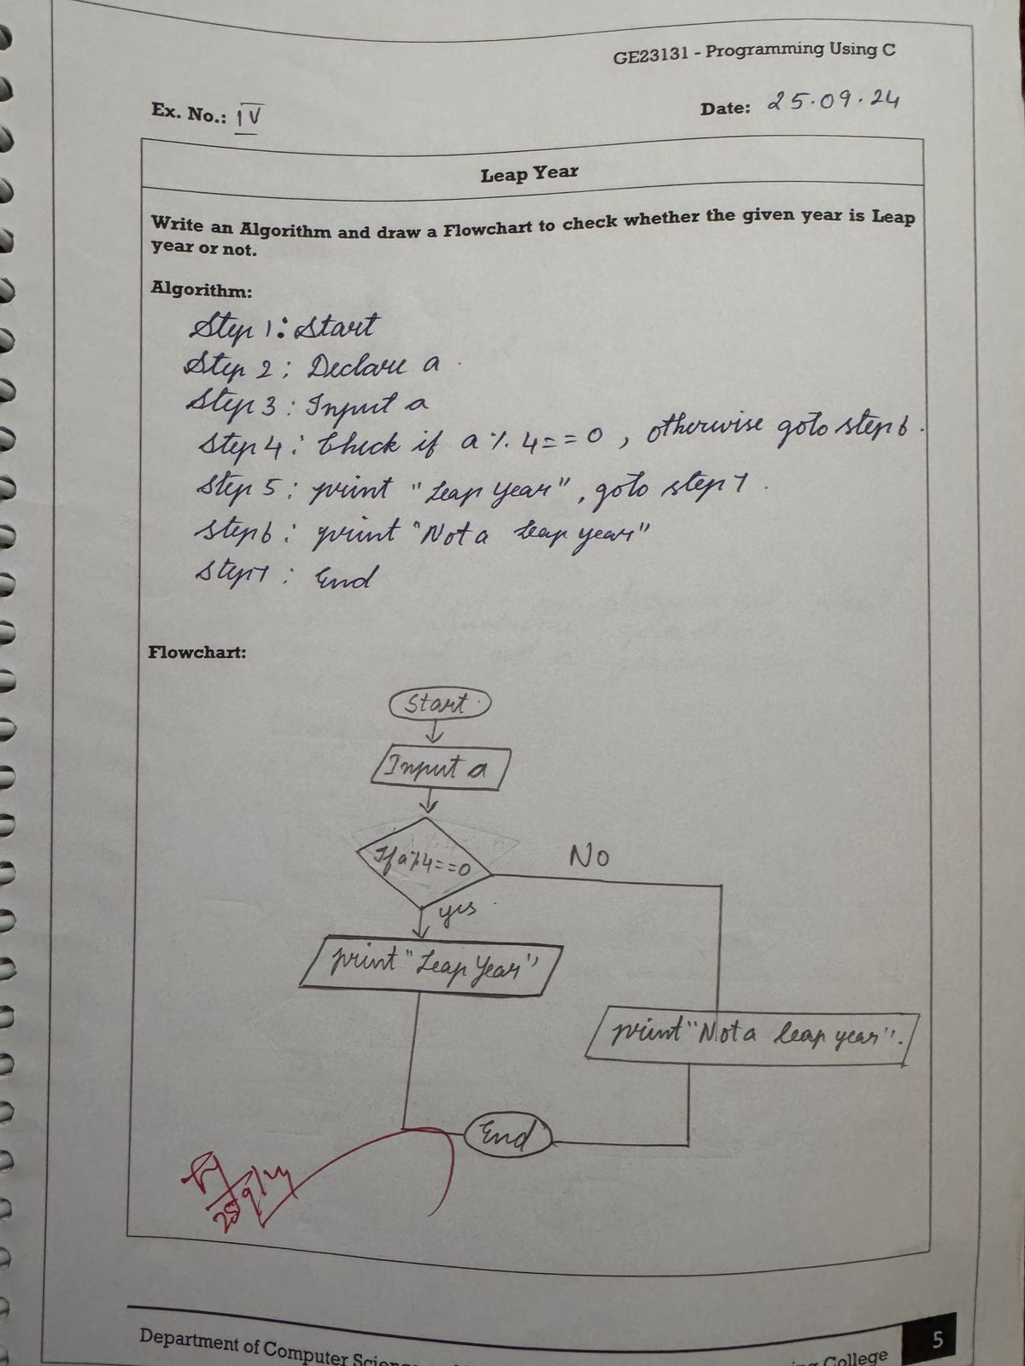
NAME: YOGADHARSHINI N K
ROLL NO:241801324
Q5) PALINDROME NUMBER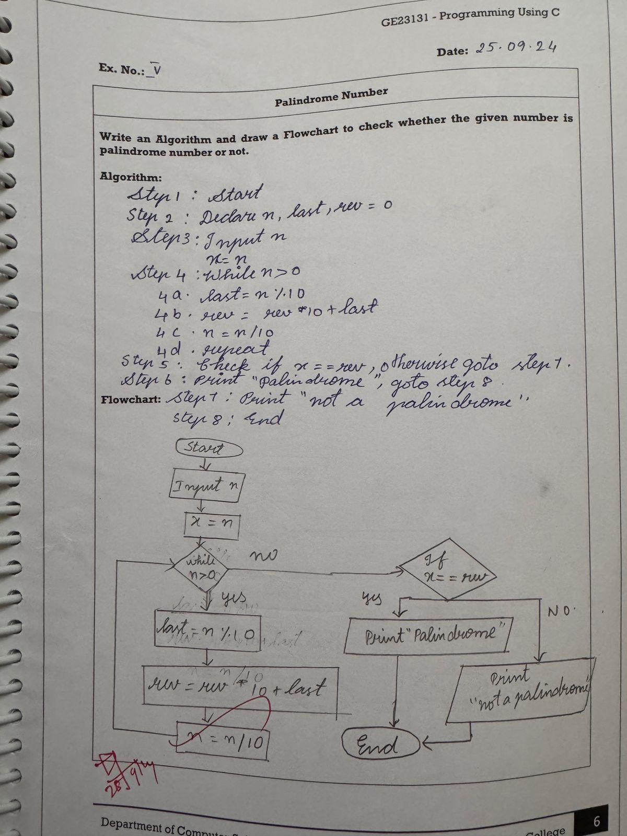
NAME: YOGADHARSHINI N K
ROLL NO: 241801324
Q6-SUM OF DIGITS